Nikhil Krishnan

CIS 580

5/5/18

Milestone 2

**Summary**

**Nonlinear Triangulation – Done**

**Linear PnP – Done**

**PnP RANSAC – Done**

**Nonlinear PnP – Done**

**Bundle Adjustment – Not Done**

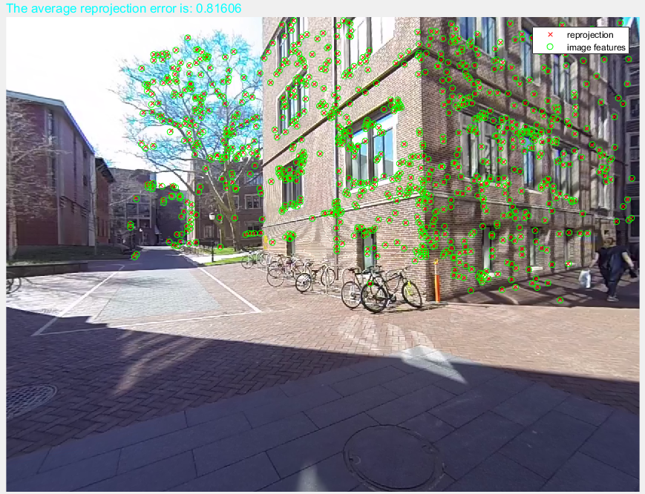

**Projection between 1 and 2**

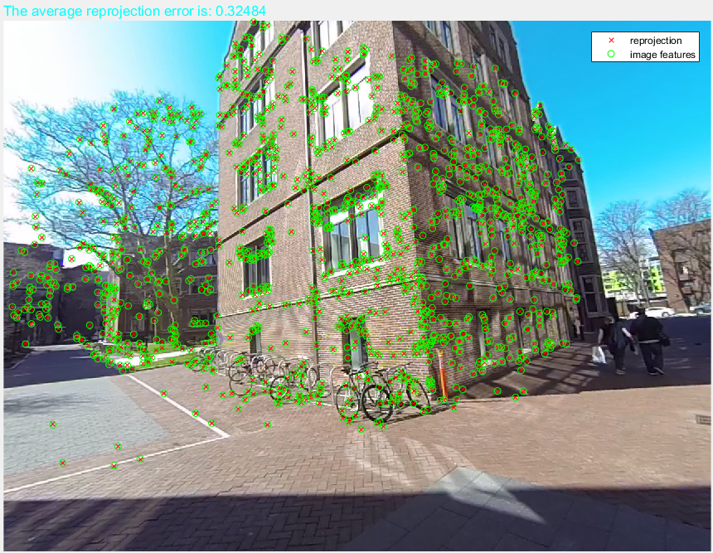

**Projection between 2 and 3**

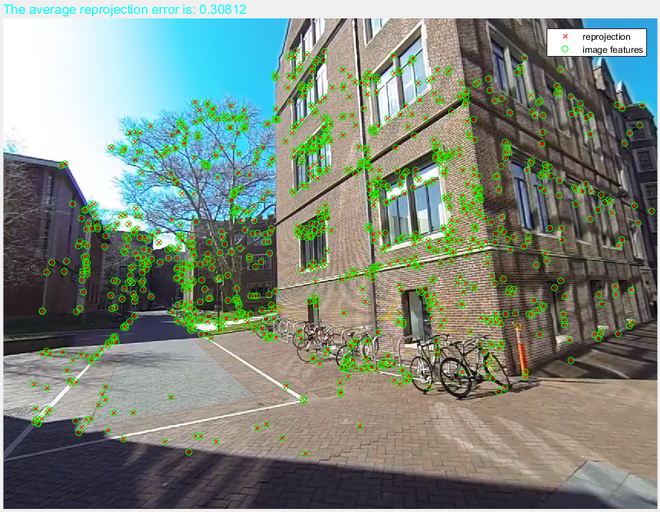

**Projection between 3 and 4**

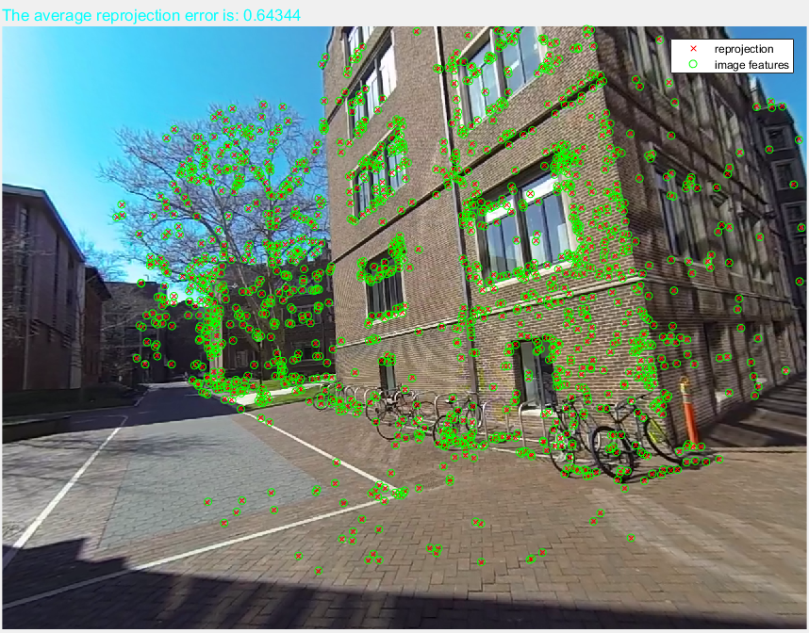

**Projection between 4 and 5**

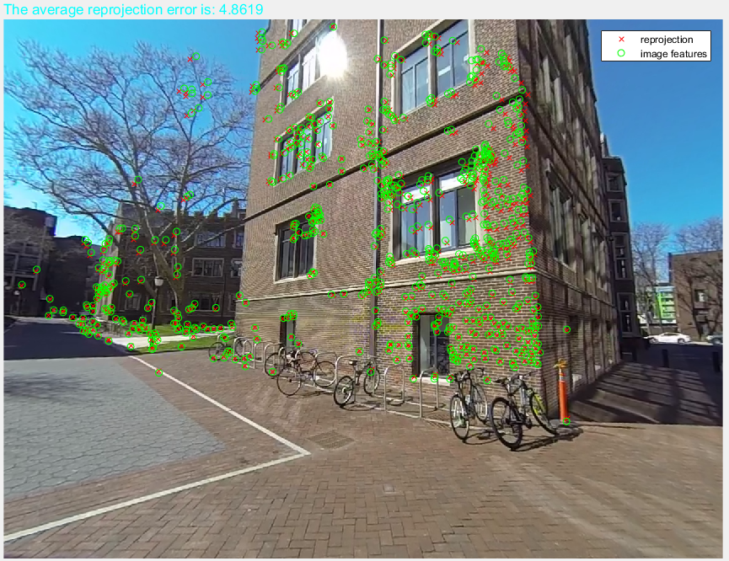

**Projection between 5 and 6**

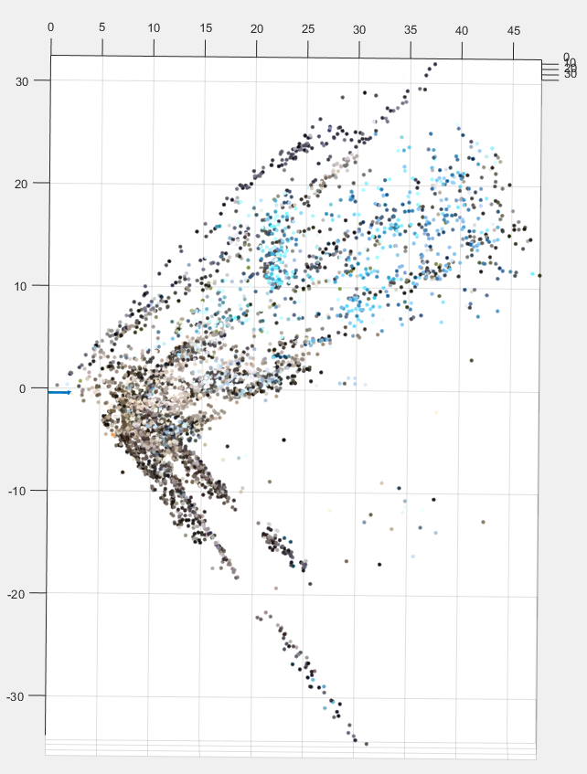

**Overall 3D point cloud**